DEVELOPMENT OF CONCRETE WATER CEMENT RATIO PREDICTION SYSTEM
ABSTRACT
This research project developed a prediction system for the water-cement ratio in concrete using Deep Neural Networks (DNNs) to improve quality, durability, and performance in construction, particularly in regions like Nigeria where environmental conditions impact concrete properties. Traditional methods for determining the water-cement ratio often lead to inconsistent quality, material wastage, and increased costs. The DNN-based model, built with a dataset from Osun State University's Department of Civil Engineering, used Python libraries for implementation and was designed to handle complex data interactions. The model, trained on 72 samples over 100 epochs, achieved high accuracy with a training loss of 0.0025, validation loss of 0.0019, Mean Absolute Error (MAE) of 0.0019, and Mean Squared Error (MSE) of 0.027 on the test set. These results indicate the model's effectiveness, robustness, and ability to generalize without overfitting
1 INTRODUCTION
Concrete is a fundamental material in modern construction, essential for projects ranging from residential buildings to large infrastructural works. Its effectiveness largely depends on the water-cement ratio, a critical parameter that determines concrete's quality, durability, and performance (Rahmani et al., 2018). This ratio, representing the mass of water to cement in a mix, directly impacts the material’s strength and overall properties (Wang, 2023). An incorrect ratio can lead to issues such as reduced strength, increased permeability, and cracking (Rahmani et al., 2018).
The importance of concrete in construction and the critical role of the water-cement ratio in determining concrete's quality, durability, and performance. Achieving the correct water-cement ratio is crucial for concrete strength, as too much water weakens the structure, while too little impairs mixing and compaction. This balance is particularly important in regions like Nigeria, where environmental conditions affect concrete mixes. The use of Deep Neural Networks (DNNs) in predicting the water-cement ratio offers significant advantages by processing vast data sets, uncovering complex patterns, and making accurate predictions. This approach can improve concrete quality, reduce material waste, and enhance structure longevity, especially under diverse environmental conditions in Nigeria.

2 LITERATURE REVIEW
Concrete composition, focusing on the water-cement ratio's critical role in determining concrete's strength and durability. It highlights the inverse relationship between water-cement ratio and concrete strength, noting that an optimal ratio around 0.4 yields the best compressive strength, while higher ratios reduce strength and affect other properties like porosity and permeability. The chapter also explores the application of deep learning models, specifically Deep Neural Networks (DNNs) and Convolutional Neural Networks (CNNs), for predicting concrete properties, emphasizing their ability to learn complex data patterns.
Recent studies have developed various machine learning models to predict concrete properties, particularly compressive strength. For example, Al-Shamiri et al. (2020) used a Regularized Extreme Learning Machine (RELM) to predict the compressive strength of high-performance concrete, outperforming traditional methods but not focusing on water-cement ratio prediction. Park et al. (2021) investigated the effect of data range on prediction accuracy using linear regression, while Huang et al. (2022) combined the firefly algorithm with Random Forest (RF) to enhance prediction reliability for ternary concrete.
Kumar et al. (2022) explored machine learning models like Gaussian Process Regression (GPR), Support Vector Machine Regression (SVMR), and Ensemble Learning (EL) to predict lightweight concrete's compressive strength, highlighting the need for diverse datasets. Li (2023) examined flexural strength prediction using Random Forest and Extreme Gradient Boosting (XGB) models, finding them superior to Linear Regression. Cho (2024) used ensemble models to predict the impact of recycled concrete aggregates on compressive strength, and Saleh et al. (2023) focused on soft computing models for strain-hardening cement-based composites, demonstrating the potential of artificial neural networks (ANNs) in prediction accuracy. While these studies improve concrete property predictions, they mainly focus on compressive or flexural strength. The current study fills a gap by specifically targeting water-cement ratio prediction, enhancing concrete mix optimization through machine learning techniques.
3 EXPERIMENTAL SETUP
Concrete water cement ratio was proposed to solve the manual and inaccurate mode of water population. Figure 3.1 shows the flow chart for the model developed using machine learning techniques. The methodology encompasses the following phases: data collection, data pre-processing, model development, data analysis, and performance evaluation. Python, along with its libraries such as Pandas, NumPy, Scikit-learn, and TensorFlow, will be utilized for implementing the deep neural network model..

3.1 DATA COLLECTION
Concrete experimental data, including the water-cement ratio, was obtained from the Department of Civil Engineering at Osun State University. The study modeled the required water content (liters/m³) for the concrete mix based on seven input features: cement (kg/m³), fine aggregates (kg/m³), coarse aggregates (kg/m³), concrete compressive strength (MPa), density (kg/m³), slump (mm), and age of testing (days). The dataset comprised 72 samples, which were divided into three subsets for model development: 70% for training, 15% for validation, and 15% for testing. Figure 3.1 presents a sample of the data.

DATA PREPOCESSING
The dataset was loaded into the Python environment using the Pandas library. This step involved reading the data from an Excel file and converting it into a DataFrame for easy manipulation and analysis. The initial exploration of the data included displaying the first few rows to understand its structure and checking for any apparent issues such as missing values or incorrect data types. Data cleaning is a crucial step in the data preparation process. In this study, the dataset did not contain any missing values, which simplified the cleaning process. The model was trained for 100 epochs with a batch size of 10, using Mean Squared Error (MSE) as the loss function and the Adam optimizer. Training and validation losses consistently decreased, reaching 0.0025 and 0.0019 by the 100th epoch, respectively. The model was evaluated on a test set using Mean Absolute Error (MAE) and MSE, achieving a test loss of 0.0019 and an MAE of approximately 0.0277, demonstrating reasonable prediction accuracy
3.3 PREDICTIVE MODEL DESIGN
The deep neural network (DNN) model for predicting the water-cement ratio was developed using TensorFlow, featuring an architecture with an input layer, three hidden layers, and an output layer. The input layer had 8 neurons for the dataset features, and the hidden layers had 21, 14, and 7 neurons, respectively, using ReLU activation functions to learn complex patterns. The output layer had a single neuron with a linear activation function for regression tasks.
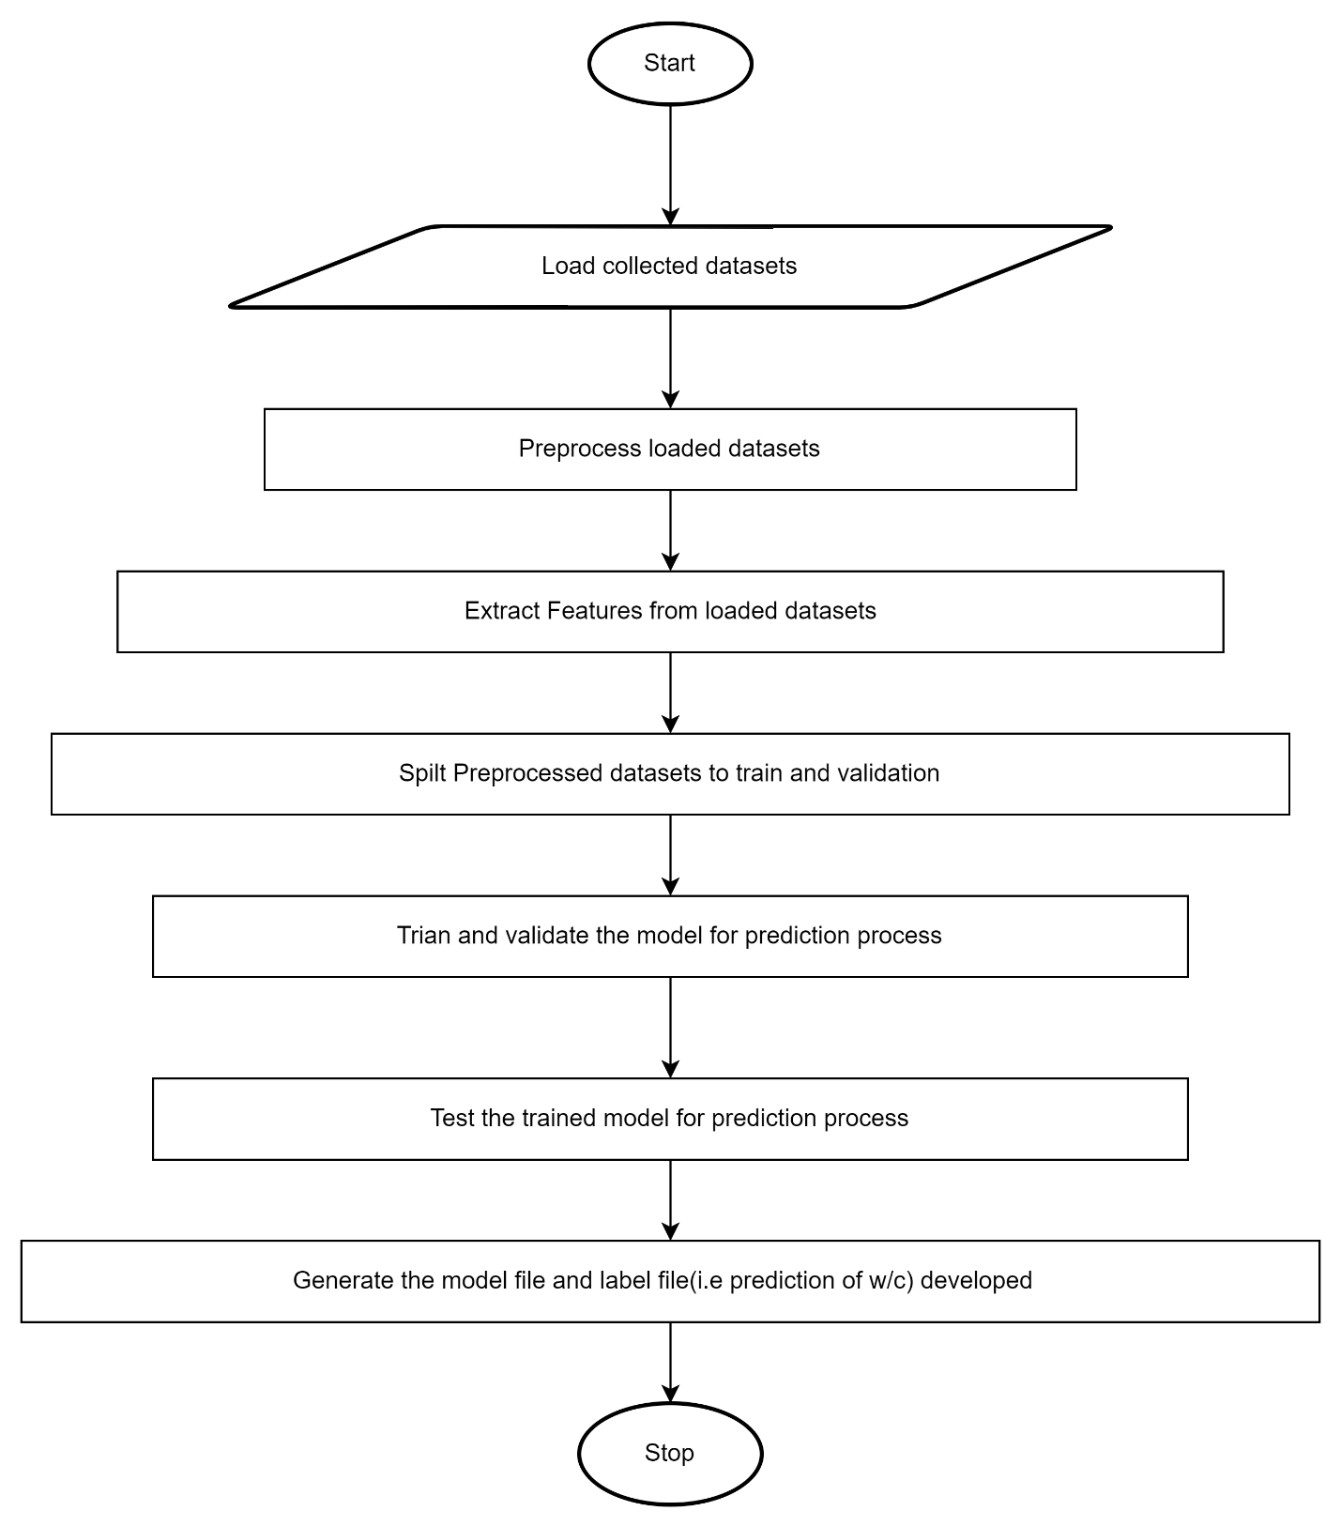

Figure 3.1: Flowchart of Concrete Water Cement Prediction Model

Table 3.1 Sample of data Collected
S/N | Cement (kg/m³) | Sand (kg/m³) | Granite (kg/m³) | Age (days) | Water (kg/m³) | w/c | Slump (mm) | Density (kg/m³) | Comp. Strength (N/mm²)
1 | 263 | 788.3 | 1576.7 | 7 | 170.95 | 0.65 | 6 | 2014 | 4.89
2 | 263 | 788.3 | 1576.7 | 7 | 170.95 | 0.65 | 6 | 2122 | 7.56
3 | 263 | 788.3 | 1576.7 | 7 | 170.95 | 0.65 | 6 | 2044 | 6.89
4 | 263 | 788.3 | 1576.7 | 7 | 170.95 | 0.65 | 6 | 2252 | 7.11
5 | 263 | 788.3 | 1576.7 | 7 | 170.95 | 0.65 | 6 | 2074 | 5.56
6 | 263 | 788.3 | 1576.7 | 7 | 170.95 | 0.65 | 6 | 2163 | 7.78

RESULTS AND DISCUSSION
The data pre-processing phase involved normalizing key features (Cement, Sand, Granite, Age, Water, Slump, Density, and Compressive Strength) to ensure consistency and prevent any feature from disproportionately influencing the deep neural network model's predictions. The dataset was split into training (80%) and test (20%) sets, focusing on variables affecting the water-cement ratio. The model was trained for 100 epochs with a batch size of 10, showing a consistent decrease in both training and validation losses, with final losses of 0.0025 and 0.0019, respectively. Model evaluation on the test set resulted in a Mean Absolute Error (MAE) of 0.0019 and Mean Squared Error (MSE) of 0.027. The predicted values closely matched actual values (Table 4.1, Figure 4.1), and the residual plot (Figure 4.4) showed residuals centered around zero, indicating unbiased predictions. Error distribution (Figure 4.5) was symmetric around zero, with most errors within ±0.01, demonstrating high accuracy and consistency. The MAE plot (Figure 4.3) over 100 epochs confirmed effective learning and generalization without overfitting

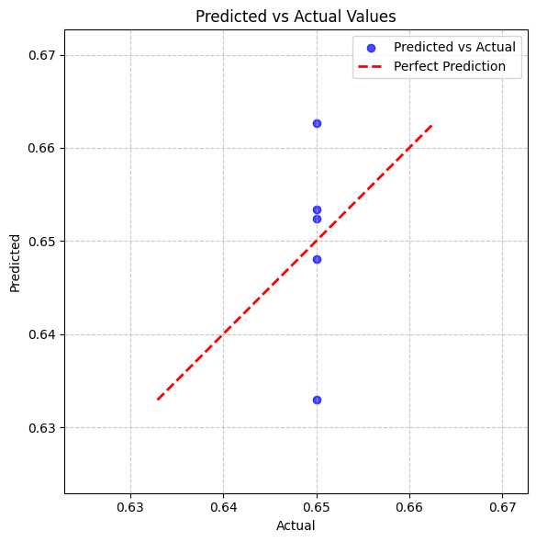
Figure 4.1: Predicted Results

Index | Actual | Predicted
4 | 0.65 | 0.66268
62 | 0.65 | 0.64805
18 | 0.65 | 0.65238
0 | 0.65 | 0.63294
28 | 0.65 | 0.65337
Table4.2: Predicted vs. actual values for the water-cement ratio

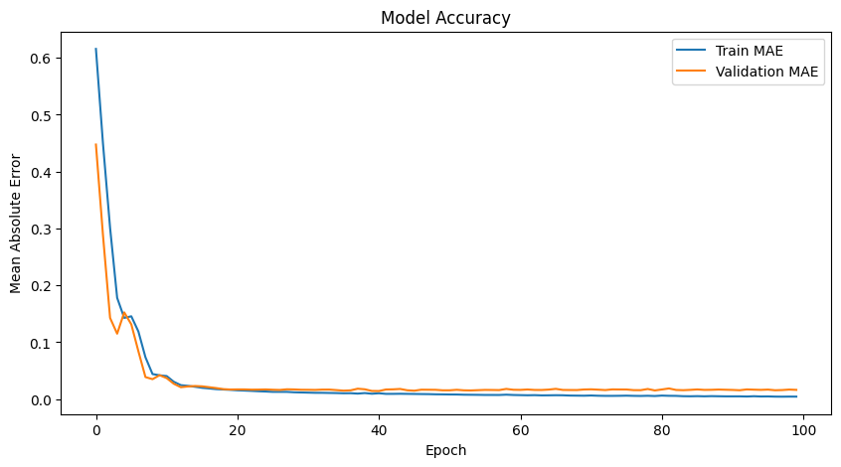
Figure 4.3 Training Accuracy and Validation of MAE values
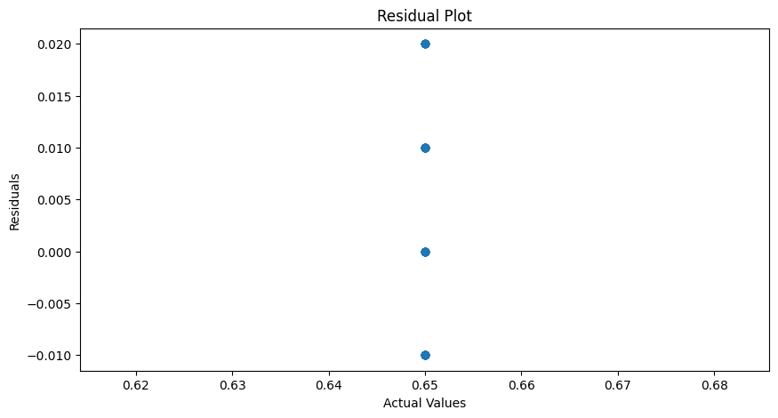

Figure 4.4: Residual plot of Predicted vs Actual values

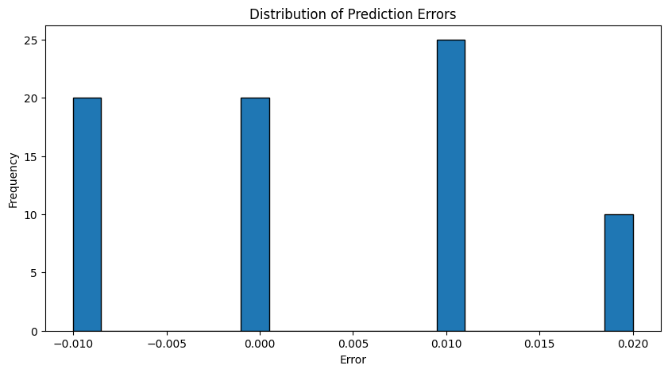
Figure 4.5: Distribution of Errors

5.1 CONCLUSION
From the results obtained in the study, the following conclusion has been drawn
- The deep neural network model demonstrated good predictive capabilities for the water-cement ratio of concrete.
- The results indicate that the deep neural network model is capable of predicting the water-cement ratio of concrete with a reasonable degree of accuracy. The low mean absolute error and mean squared error suggest that the model's predictions were close to the actual values
- Despite the positive results, there are some limitations to this study. The dataset was relatively small, comprising only 72 samples, which may limit the model's generalizability. Additionally, the model's performance could be further improved by exploring different neural network architectures, hyperparameters, and additional features

REFERENCES
- Al-Shamiri, A., Yuan, T., & Kim, J. (2020). Non-tuned machine learning approach for predicting the compressive strength of high-performance concrete. Materials, 13(5), 1023. https://doi.org/10.3390/ma13051023
- Almasaeid, H. and Salman, D. (2022). Application of artificial neural network to predict the properties of permeable concrete. Civil Engineering and Architecture, 10(6), 2290-2305. https://doi.org/10.13189/cea.2022.100605
- Barkhordari, M. (2024). Predicting autogenous shrinkage of concrete including superabsorbent polymers and other cementitious ingredients using convolution-based algorithms. Periodica Polytechnica Civil Engineering. https://doi.org/10.3311/ppci.23568
- Chen, H., Qian, C., Liang, C., & Kang, W. (2018). An approach for predicting the compressive strength of cement-based materials exposed to sulfate attack. Plos One, 13(1), e0191370. https://doi.org/10.1371/journal.pone.0191370
- Cho, S. (2024). A meta-analysis of the effect of moisture content of recycled concrete aggregate on the compressive strength of concrete. Applied Sciences, 14(8), 3512.

